Daily Email Triage and Digest Agent 📧

An AI-powered workflow that automatically processes emails and creates a daily summary.

Goal of the Project 🎯

The main goal is to automatically analyze emails, identify important information, summarize them, and send a daily briefing to the user, saving time and effort.

Objectives of the Project
• To automatically collect emails.
• To identify important and urgent messages.
• To summarize email content using AI.
• To organize multiple emails into one summary.
• To send the final summary as a message to the telegram.

Requirements of the Project ⚙️
Schedule Trigger → Gmail → Aggregate → AI Agent → Gemini → Send Message
- Schedule Trigger: Starts the workflow automatically at a scheduled time.
- Gmail: Collects the emails.
- Aggregate: Combines multiple emails into one collection.
- AI Agent: Analyzes and summarizes the emails.
- Google Gemini: Helps the AI understand the email content.
- Telegram: It delivers the AI-Generated emails summary in one message to the user
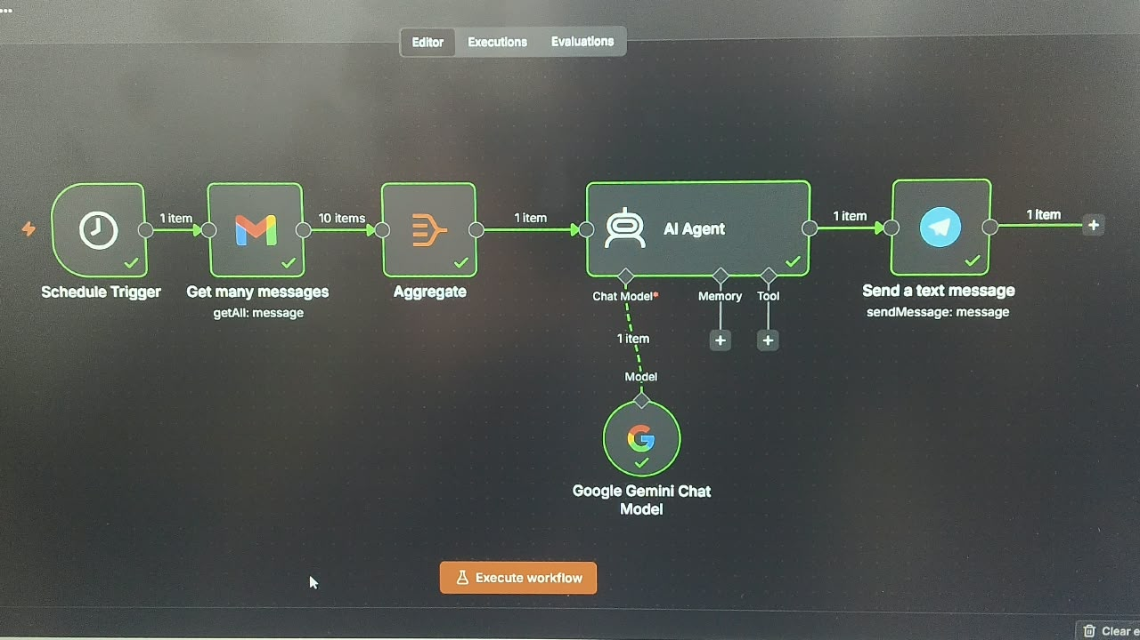

Output 📱
The AI classifies emails into three categories: Urgent, Important, and Normal.
The categorized summary is automatically sent to the user through Telegram.
